**Title I Guidelines and Procedures**



**2023-2024**

**School Year**

**Guide to Use** 4

**Title I Information** 5

Title I Staff6

Title I Schools 7

Title I Comprehensive School Wide Planning 8

Title I Components Clarification 11

Title I Low Performing Schools 13

NCStar 14

Student Support and Academic Enrichment 15

12 Indictor Process 16

12 Key Indicators 17

**School Improvement**

Highlights of ESSA 19

Title I Schoolwide Program Calendar 22

Transportation 24

**Title I Plan/Budget Information**

Guidelines for Using Title I Funds 26

Title I Budget 28

Title I Allowable and non-Allowable Cost Reference Guide Examples 31

Title I Funding 36

Sample Title I (050) Allocation Summary 37

**Purchase Orders/Invoices/Reimbursements**

The Process of Submitting a Purchase Order Using Title I Funds 39

Title I Purchasing Guidelines 40

Things to Remember 42

Workshop/Reimbursement Checklist 44

Sample Estimate of Travel Expenditures Form 45

Sample Purchase Order-Ordering Supplies 46

Sample Purchase Order: Parent Involvement Reimbursement 47

Sample Purchase Order Review 48

**Contract, Notice to Pay and Timesheets**

Title I Contracts 50

Contract Reminders 52

Sample Contracts 53

Title I Timesheets 54

Budgeting Codes 55

Sample Copy of Employee’s Daily and Monthly Time Report 56

**Parent Family Engagement**

Parental Family Engagement Activities 58

Parent Family Engagement Evaluation 59

Example Elementary School Title I PE Policy 60

Parent Engagement Policy Requirements 63

Parent Family Engagement Plan 65

**Forms**

Semi-Annual Blanket Certification: Pre-K **(Aug.-Dec.)** 68

Semi-Annual Blanket Certification: Pre-K **(Jan.-June)** 69

Semi-Annual Blanket Certification: Federal 050 **(Aug.-Dec.)** 70

Semi-Annual Blanket Certification: Federal 050 **(Jan.-June)** 71

Title I Parent Meeting Sign-In Sheet 72

Move Money Form 73

Purchase Order Request Form 74

**Guide to Use**

This guide was created to answer questions that administrators, office staff, teachers, and others may have regarding compliance to federal guidelines as they relate to the operation of Title I programs. General information is provided in the enclosed sections, followed by forms referenced in the guide. Title I and Pitt County Schools’ guidelines are constantly changing. Please note that the contents are current to the time of publication. Updates will be provided as appropriate.



**Title I Information**



**Federal Programs Office Staff**

**Dr. Shannon Cecil**

[cecils1@pitt.k12.nc.us](mailto:cecils1@pitt.k12.nc.us)

Federal Programs Director

252.695.7950

|  |  |
| --- | --- |
| **Shonda Adams**  ESL Testing Specialist  [adamss2@pitt.k12.nc.us](mailto:adamss2@pitt.k12.nc.us)  252.695.7953 | **Hannah Butler**  Coordinator of Global Education  [butlerh@pitt.k12.nc.us](mailto:butlerh@pitt.k12.nc.us)  252.695.7957 |
| **LaReesha Carter**  Federal Programs Administrative Support  [carterl@pitt.k12.nc.us](mailto:carterl@pitt.k12.nc.us)  252.695.7951 | **Patricia Cox**  Title I Specialist  [coxp@pitt.k12.nc.us](mailto:coxp@pitt.k12.nc.us)  252.695.7956 |
| **Priscila Kelly**  Bilingual Family Liaison  [kellyp@pitt.k12.nc.us](mailto:kellyp@pitt.k12.nc.us)  252.695.7954 | **Twanda Staton**  Parent Engagement Coordinator  statont2@pitt.k12.nc.us  252.695.7952 |
| **Sonja Messick**  Federal Grants Financial Analyst  [warrens@pitt.k12.nc.us](mailto:warrens@pitt.k12.nc.us)  252.830.4253  252.830.4262 (fax)  1717 West Fifth Street  Greenville, NC 27834 | Title I at SFMHS - South Fort Myers High School |

**Title I Schools**

**2023-2024**

**A.G. Cox (6-8) Ayden Elem. (PK-5) Ayden Middle (6-8)**

**Belvoir (PK-5) Bethel (PK-8) Chicod (K-8)**

**C.M. Eppes (6-8) Creekside (K-5) Eastern (K-5)**

**E.B. Aycock (6-8) Elmhurst (K-5) Falkland (K-5)**

**Farmville Middle (6-8) Grifton (PK-8) G.R. Whitfield (PK-8)**

**H.B. Sugg (PK-2) Innovation HS (9-12) Lakeforest (PK-5)**

**Northwest (PK-5) Pactolus (PK-8) PCS Early College (9-12)**

**Ridgewood (K-5) Sam D. Bundy (3-5) South Greenville (PK-5)**

**Stokes (K-8) Wahl-Coates (PK-5) Wintergreen Int. (3-5)**

**Wintergreen Pri. (K-2) Wellcome (6-8) W.H. Robinson (K-5)**

**Title I Comprehensive School-wide Planning**

**SCHOOL**

**in consultation with**

**LEA**

**PARENTS**

**COMMUNITY**

**TECHNICAL**

**ASSISTANCE PROVIDER**

Entire school community responsible for success and growth of every student—”No Excuses”

**5-Step Process**

1. Establish the Title I team

2. Clarify the vision for reform

3. Create a school profile

4. Identify data sources

5. Analyze the data

**Analyze and review the existing plan**

* Describe how the school will carry out each of the required school wide components
* Describe how the school will use Title I resources and other resources to carry-out the school wide components
* Include a list of State and local programs the school will consolidate in the school wide program
* Be evaluated annually—looking at both program implementation and achieved results
* Be revised as necessary to ensure continuous student improvement

**Identify the 10 school wide components in your plan**  [[

Title I section 1114(b)(1)]

1. Comprehensive needs assessment summary

2. School reform strategies

3. Highly qualified personnel

4. High quality and ongoing professional development

5. Strategies to attract and retain highly qualified staff

6. Parent involvement

7. Transition strategies

8. Teacher involvement in assessment use

9. Instructional activities for students experiencing difficulty

10. Coordination/integration of federal, state, and local

services/programs

**Focus on High Student Achievement**

* Include school vision and mission
* Address identified educational priorities
* Develop in collaboration with other school programs (e.g., EC, AG, grant-funded, individual school initiatives
* Address areas that impact student achievement (e.g., student needs, curriculum and instruction, professional development, family and community involvement, school context and organization)

**High Expectations**

* Work hard to succeed—both teachers and students
* Challenge students to think more deeply, apply new knowledge and skills, and become self-motivated learners
* Challenge each staff member to believe in each student’s ability to achieve to high standards
* Focus on intensive, early intervention to bring students up to grade level
* Provide opportunities for students to build meaningful relationships with adults
* Write **S**.**M**.**A**.**R**.**T**. goals

**S**: Specific (clear and explicit)

**M**: Measurable (accomplishment)

**A**: Attainable (realistic and controllable)

**R**: Relevant (related to identified needs)

**T**: Time bound (beginning, interim, end)

**Data-driven Instruction**

* Use data to identify students’ strengths and weaknesses
* Use multiple data sources (profiles, surveys, formal and informal assessments, student work samples) to make informed decisions
* Use data to make informed decisions and determine areas of need
* Use multiple daily and weekly student assessments for ongoing data collection
* Focus on mastery by monitoring student progress using assessments to calibrate and retool
* Adjust teaching strategies to meet students’ needs based on the data

Analyze the

**Analyze the Data**

* Establish a process to review the data
* Determine any gaps between the vision and the current findings
* Summarize the data
* Draw conclusions
* Share the findings with the educational community
* Prioritize the needs
* Determine how to meet the needs
* Build an ongoing plan to facilitate continuous planning

Comprehensive

**Professional Learning**

* Seek opportunities to acquire new content knowledge and instructional skills
* Share what works—skills and strategies—with one another
* Establish learning communities—vertical teams made up of teachers, aides and staff, cutting across grade levels
* Include culturally responsive training in content and skills
* Collaborate with colleagues to identify solutions to barriers

**Parent Outreach**

* View parents as critical partners in the educational process
* Solicit and facilitate parental participation
* Create opportunities for parents to join in the life of the school and share learning experiences with their children
* Offer parents opportunities to collaborate with the school both when planning and making decisions about their child
* Create a climate of cooperation between school, parents, and the community

**Can-do Spirit**

* Commit to continuous student progress
* Convey genuine caring
* Honor students and their heritages
* Extend learning time
* Give students access to timely, effective, extra instruction if necessary
* Use rigorous and challenging content standards
* Accelerate and enrich the curriculum
* Teach them to learn with understanding
* Provide opportunities to excel in areas of special interest

**Title I Components Clarification**

**Comprehensive Needs Assessment**

* Establish a planning team of educators, parents and community members to review school needs and create a vision for schoolwide reform each year
* Use school data to determine areas of strength and weakness and plan reform
* Implement best practices that support school improvement and school needs

**School Reform Strategies**

* Identify low performing areas and strategies used to address those areas
* Instructional strategies that support school wide reform or improvement (Blended Learning, Instructional Coaches, MTSS, etc.)
* Procedures to identify low performing students, strategies need for those students, how progress will be monitored, and how parents are informed of progress.
* Specific strategies used to decrease achievement gap
* Describe availability of extended day opportunities that address increasing student achievement (tutoring/remediation, before, after or during)
* Describe procedure for identifying and targeting minority, poverty and language limited students and strategies used to address the needs of these populations.

**Highly Qualified Staff**

* Identifying professional development activities to enhance instructional practices
* Plan for all provisionally licensed teachers and teacher assistants to become highly qualified
* Plan to ensure that all staff is HQ by monitoring staff placement

**Teacher Recruitment and Retention**

* How you use assessment data to place highly qualified teachers in areas of need, including the use of “reduced class size” positions.
* Strategies used to recruit/retain highly qualified teachers
* Recruitment initiatives at the schools level in terms of climate issues, administrative support for teachers (planning, staff development, lead teacher and/or mentor support) and any incentive program that may exist.

**Grade Transition: PreK – K, Elem., Middle, and/or Middle-High School**

* Describe your transition strategies and how transition entities work with one another (ex. How do you plan activities at your school to help students transition from one grade to another)
* Programs that transition from one grade to the next (PBIS, etc.)

**HQ Staff Development**

* Target staff development that address specific subgroups
* Schoolwide training for all certified teachers and teacher asst.
* Supports research based strategies/district goals

**Instructional At-Risk/Assistance**

* Lists steps or provide copy of procedures to identify students of placement in Exceptional Children’s Programs, ESL/LEP, etc.
* Describe professional development activities planned that will assist teachers in teaching and addressing needs of student s with identified needs and different learning styles.
* Discuss how technology and extended day opportunities are used to address needs of this population
* Strategies used to improve instruction with at-risk students
* Programs that address the needs of at-risk student population

**Teacher Involvement/Input**

* Describe how teachers use data to drive instruction? Analyze data and assessments to improve instruction.
* Teachers developing assessments using technology to improve student performance.
* Teacher knowledge of using different assessment with students

**Federal, State and Local Support**

* Describe collaborations you have with other programs, grants, agencies or local/civic or church organizations.
* Local or district wide initiatives/programs
* Programs supported by DPI
* Strategies are supported by federal, state or local funds

**Parent Involvement**

* Events that promote student involvement across the curriculum
* Annual Title I meeting activities
* Activities that promote a positive home/school relationship
* Strategies that enhance communication between school and parents

**Pitt County Schools**

**Title I Low Performing Schools (17)**

**Ayden Middle (6-8)**

**Belvoir Elementary (K-5)**

**Bethel School (K-8)**

**CM Eppes (6-8)**

**Creekside Elementary (K-5)**

**Eastern Elementary (K-5)**

**E B Aycock (6-8)**

**Falkland Elementary (K-5)**

**Farmville Middle (6-8)**

**Grifton School (K-8)**

**Lakeforest Elementary (K-5)**

**Northwest Elementary (K-5)**

**Pactolus (K-8)**

**Sam Bundy Elementary (3-5)**

**South Greenville Elementary (K-5)**

**Wahl-Coates Elementary (K-5)**

**Wellcome Middle School (6-8)**

**Targeted Support and Improvement Schools**

**(TSI)/CSI**

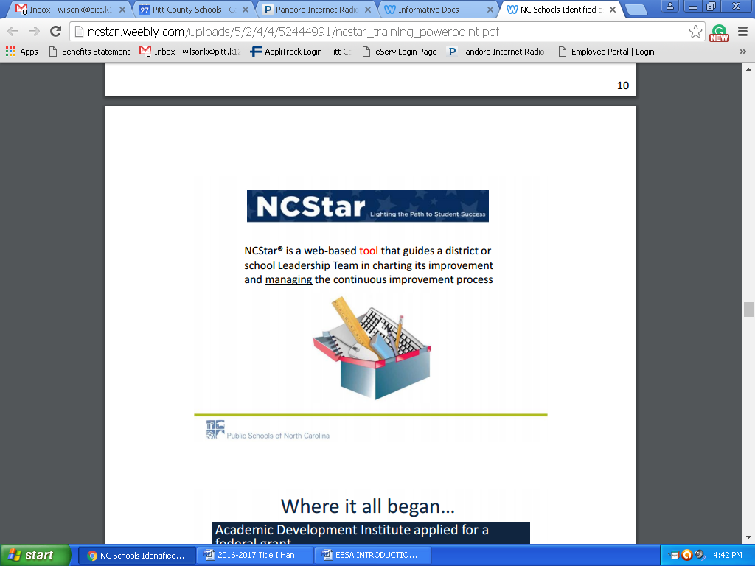

**\*Title I Schools will use NCSTAR to monitor the School Improvement Planning for their school. Two meeting should be held each month to discuss the school indicators.**

**\*Meeting minutes must be recorded in NCSTAR.**

**\*All Low Performing Schools will complete the Comprehensive Progress Report in the Fall and Spring in NCSTAR**

**Student Support and Academic Enrichment**

**The Every Student Succeeds Act (ESSA) includes a number of provisions that promote equitable access to educational opportunity, including holding all students to high academic standards, ensuring meaningful action is taken to improve the lowest-performing schools and schools with underperforming student groups, and providing more children with access to high-quality preschool. The Student Support and Academic Enrichment (SSAE) program, authorized under subpart 1 of Title IV, Part A of the ESSA, is intended to help increase the capacity of local educational agencies (LEAs), schools, and local communities to: 1) provide all students with access to a well-rounded education; 2) improve school conditions for student learning; and 3) improve the use of technology in order to improve the academic achievement and digital literacy of all students.**

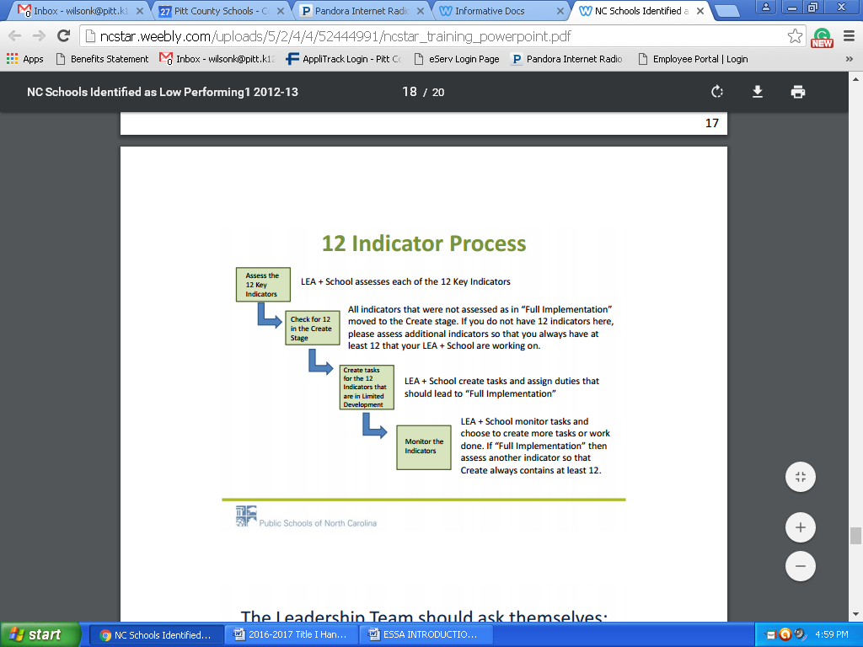

**The 12 Key Indicators**

* All teachers employ effective classroom management and reinforce classroom rules and procedures by positively teaching them.
* Instructional Teams develop standards-aligned units of instruction for each subject and grade level.
* The school implements a tiered instructional system that allows teachers to deliver evidence-based instruction aligned with the individual needs of student across all tiers.
* All teachers are attentive to students’ emotional states, guide students in managing their emotions, and arrange for supports and interventions when necessary.
* The school develops and implements consistent, intentional, and on-going plans to support student transitions for grade-to-grade and level-to-level.
* The LEA has an LEA Support & Improvement Team
* A Leadership Team consisting of the principal, teachers who lead the Instructional Teams, and other key professional staff meets regularly (twice a month or more for an hour each meeting) to review implementation of effective practice.
* The school has established a team structure among teachers with specific duties and time for instructional planning.
* The principal monitors curriculum and classroom instruction regularly and provides timely, clear, constructive feedback to teachers.
* The LEA/School regularly looks at school performance data and aggregated classroom observation data and uses the data to make decisions about school improvement and professional development needs.
* The LEA/School has established a system of procedures and protocols for recruiting, evaluating, rewarding, and replacing staff.
* The school regularly communicates with parents (families) about its expectations of them and the importance of the curriculum of the home (what parents can do at home to support their children’s learning.

**SCHOOL IMPROVEMENT**



**Brief Highlights of the Every Student Succeeds Act (ESSA)**

*The President of the United States signed the Every Student Succeeds Act (ESSA) bill into law on December 10, 2015. The Elementary and Secondary Education Act (ESEA) was eight years overdue for reauthorization, and the ESSA is a critical step forward. Here are some (but not all) aspects of the new law:*

**General**

* It places many limitations on the authority of the US Secretary of Education and this includes the inability to require additions or deletions to a state’s academic content standards or to prescribe specific goals of progress, specific assessments, weights of measures or indicators, etc.
* The U.S. Department of Education (USED) will still need to issue regulations but they cannot add new requirements that go beyond what is required in the law.
* All current ESEA Flexibility Waivers will be null and void as of August 1, 2016. However, any schools currently identified as priority and focus schools must be maintained for the 2016-17 school year.

**State Plan**

* There currently is no timeline established for when the new regulations will be issued or by when and how states will submit their plans to the USED.
* It requires involvement of various stakeholders including timely and meaningful consultation with the governor in the development of the state’s plan. The governor must be given 30 days to sign the plan, but it can be submitted to the USED after the 30 days even if the governor does not sign it.
* Implementation of new state plans (once approved by the USED) will start with the 2017-18 school year.

**Assessments, Accountability and Reporting**

* It maintains annual assessments in grades 3-8 and high school.
* It reaffirms that states are in control of their standards (which must be challenging) and assessments.
* It sets parameters for a state’s accountability systems, but gives each state the flexibility to design a school accountability system that best meet the needs of the students in the state. This will include the issue of “n-size” for subgroup accountability.
* It eliminates the phrase “adequate yearly progress” (AYP).
* It maintains a 1% cap on students with the most significant cognitive disabilities, but applies the cap to the number of these students taking alternate assessments and not to capping the percentages of these students being deemed proficient for accountability purposes as under the former law. If an LEA exceeds the 1% cap, it will have to justify it to the state education agency.
* It provides for innovative assessment pilots at the state level so states can research new and improved methods of measuring student progress from year to year. Up to seven (7) states may be selected but that number could increase over time. It will be up to the Secretary of Education to determine the application process and timeline for submission to be one of the pilot states.
* The accountability plans must include goals for academic indicators (improved academic achievement on State assessments, a measure of student growth or other statewide academic indicator for elementary and middle schools, graduation rates for high schools, and progress in achieving proficiency for English Learners) and a measure of school quality and student success (examples include student and educator engagement, access and completion of advanced coursework, postsecondary readiness, school climate and safety). Participation rates on the assessments must also be included in the plan.
* Students with limited English proficiency will be allowed to remain in the English Learner (EL) subgroup for up to four (4) years after exiting the EL classification. This prevents the EL subgroup from always having students with the lowest levels of English proficiency for accountability purposes.
* It maintains many reporting requirements including the State Report Card (SRC). SRC data are expanded to include information on homeless students, foster youth, and students of parents on active duty in the military, information on acquisition of English proficiency by English Learners and professional qualifications of teachers.

**Teacher Quality**

* It gives states the flexibility to work with local stakeholders to determine how educators should be evaluated and supported each year.

**District and School Interventions**

* There is no set of required federal sanctions, but interventions used in schools needing assistance and support must be **evidence-based.**
* States will have to identify, at a minimum, the lowest 5% of Title I schools and high schools with graduation rates lower than 67%. These are the schools that are part of Comprehensive Support and Improvement (CSI).
* LEAs must develop and implement CSI plans for lowest-performing schools – State must approve plans o States also have to identify schools with consistently underperforming subgroups for Targeted Support and Improvement (TSI).

**Funding and Formulas**

* It eliminates the federal School Improvement Grants (SIG), but allows states to reserve 7% of Title I funds to make grants available to low-performing schools.
* A portion of State Assessment grants will be made available as a separate allocation to states to conduct audits of state or local assessments as a way to reduce redundant assessments. It combines some 50 programs into a big block grant under Title IV.
* Finally, it authorizes a Preschool Development Grants Program through the Department of Health and Human Services.

|  |  |
| --- | --- |
| **July**  **Title I School-Wide Program**  **Calendar** | **August** |
| * Submit draft ESEA parent notification, if Focus or Priority School * Store files-Keep Title I documents for 5 years * Submit POs Recommendation Forms for upcoming year needs to be done in Applitrack * Update Title I Plan * Catalogue Title I purchases * **Read Title I Guidelines/Procedures** * Set up meetings w/Federal Programs Director if needed * Select teachers to attend PD * Comprehensive Needs Assessment * NCSTAR | * Schools revisit School Improvement Plans * Revise School Title I Plan * Send home Parent Notification-Priority/Focus School * Select Title I Contact * Update Budget sheet with correct teacher names and changes before school starts * Catalogue Title I Purchases * Submit Focus School Plan * Submit Comprehensive Needs Assessment 2022-2023 * Leadership Team Professional Development |
| **September** | **October** |
| * Schools Conduct Annual Title I Parent Meeting * Schools Submit Principal’s Attestation * Develop Prioritized Plan * Submit budget amendment * Schools submit School Improvement Plans, if applicable * ESL Classes begin after testing (Contact Federal Programs Director and ESL Contacts) * Send home letters to parents about HQ Status of teachers/TA’s (Parent’s Right to Know) * Need to update Title I Plan * Catalogue Title I purchases | * Submit copy of verification letter to Title I office of the Parents Rights to Know letter * Technical Assistance for Focus/Priority School * Set up ESL Tutorial Groups * Need to update Title I Plan * Catalogue Title I purchases * Review/Edit School Data Summary * Analysis * Focus Schools Meeting * Title I Contact Meeting * Title I Finance Meeting |
| **November** | **December** |
| * Update Title I Plan * Catalogue Title I purchases * Upload documents on website * Parent Conferences- (Compact) | * Update Title I Plan * Catalogue Title I purchases * First Title I Website Review will be conducted |
| **January** | **February** |
| * LEA Planning/Instructional Services Input * Final PO requisitions for computers * **75% of Title I funds should be spent** * Submit Semi-Annual Certification Forms * Update Title I Plan * Catalogue Title I purchases * Upload documents to website | * Spend Title I Funds before deadline * Update Title I Plan * Catalogue Title I purchases |
| **March** | **April** |
| * Assistant Principal Meeting * Update Title I Plan * Catalogue Title I purchases | * Catalogue Title I purchases * Complete and return School Data and Summary Analysis-Focus Schools * Update Title I Plan * Catalogue Title I purchases * Schools need to notify Federal Programs of summer programs |
| **May** | **June** |
| * Title I Principal Meeting * Receive Title I Planning Allocation * Analyze parent involvement attendance * Update Title I Plan * Catalogue Title I purchases * Title I Inventory is due * Final Title I Website Review | * Annual program review * Submit Semi-Annual Certification Form * Turn in planning documents for 2024-2025 * Turn in:   -Title I Budget  -Parent Involvement Plan  -Parent Involvement Policy  -Parent Involvement Requirements  -State of Assurance  -Parent Involvement Workshops  (Dates/Times) for 2023-2024 year |

**Transportation**

**Yellow Buses/Activity Buses**

Title I will pay for transportation when it is used for after school tutoring services. If a yellow bus is used for services, the Transportation Department will invoice the school. The invoice will include all costs associated with yellow buses. The original invoice should be signed by the principal and sent to the Title I department for payment along with a purchase order and **student’s roster**.

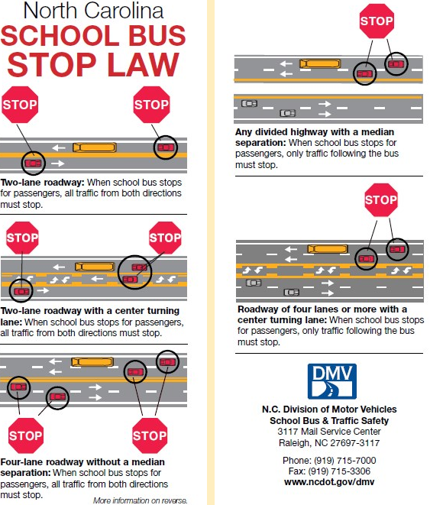

**Title I Plan/Budget**

**Information**



**Guidelines for Use of Title I Funds**

Title I schools must ensure that funds support efforts to improve performance of all students with particular attention to students who are failing, or at risk of failing to meet at minimum, the NC academic proficiency standards on state academic assessments.

1. Funds may be used to **supplement, not supplant**, other state and local resources for improving the instructional program.
2. All expenditures should be reflected in the School Improvement Plan (SIP) **and** on the Title I Prioritized School Plan, and should have a strong likelihood of impacting the instructional program in the current year. Inappropriate expenditures may require alternative funding sources.

Planning budgets are developed in the spring proceeding the implementation year based on the planning allocation provided to each school. School planning budgets are incorporated into the district application, and submitted to the NC Department of Public Instruction for review and approval. Once approved, adjustments to the budget must be approved by the local School Board and DPI.

Funds allocated during a fiscal year are to be:

1. Expended during the same time period, and with the exception of school improvement funds
2. Do not carry-over at the school level to the next year.
3. Funds from one year’s allocation may not be used to pay for activities occurring in another fiscal year.

**Recommended Expenditures:**

* Instructional Staffing
* Additional classroom teachers
* Resource teachers in core areas
* Extended time programs (before/after school, Saturday, summer) for lowest performing students and related expenses (i.e. tutor salaries, transportation)
* Pre-kindergarten program (salaries, materials, parent involvement, professional development)
* Instructional materials/supplies
* Instructional technology
* Parenting education activities and supplies
* High quality professional development activities and materials

**Plan ahead and always adhere to Finance Department policies and procedures as outlined by Pitt County Schools for all Title I funded expenditures.**

**Please Note**

All Title I schools are required to complete the following documents:

1. Comprehensive Needs Assessment

2. Prioritized Plan

3. School Improvement Plan

4. Title I Budget Worksheet

5. Principal Attestation Form

6. Parent Engagement Worksheet

7. Parent Engagement Plan

8. Parent Engagement Policy

9. Statement of Assurance

10. Title I Information Checklist

11. Semi-Annual Form

12. Title I School Student-Parent-Teacher-Administrator Compact

**Title I Budget**

**A. Personnel** – As you revise your budget, think about the following:

(See Title I SalaryAllocations)

* Number of teachers paid from Title I
* Salaries of those teachers
* Consider salary exchanges (salary swap). Exchanges may only be used for teachers serving students (not facilitators, counselors, etc.) and must be exchanged with a job-alike person (classroom teacher exchanged for another classroom teacher, not Art or Music teacher).
* If you are replacing a teacher with a Title I teacher that you have swapped, please indicate that on the Interview Recommendation Form or the HR Change Form.
* Amendments to Title I plan can be done during the year. Please complete a Federal Programs “Move Money Form” when transferring Title I funds to another budget code.
* Before Interview Recommendation Forms can be processed, an update budget must be sent to Patricia Cox. If you do not send an update budget, the Move Money form, **will not** be approved.

**B. Instructional Supplies and Materials**

* Materials purchased with Title I funds must be directly linked to instruction, student achievement, and the Comprehensive School Plan.
* By January, 75% of the school’s Title I instructional supplies and materials amount should be spent.
* Must submit a PO Request form with all PO’s.
* **All invoices for materials must be in the Federal Programs Office by March 31. Title I (050) funds will not be available after this date.**
* Will be monitored by the Federal Programs Director monthly.

**C. Use of Title I funds**

* Use Title I funds to **supplement** other fund sources, not to provide district-adopted textbooks, teacher editions, or basic items that are found in classrooms as part of a new classroom equipment and supply setup.
* **Avoid** **using Title I funds for the following:**
  + Copier payment
  + Items for teachers (selected items)
  + Food **can only be used** for a Title I Parent Involvement activity. In such case, **an agenda and a dated sign-in sheet for the activity must be attached to the food invoice) Maximum amount to be spent on food is $4.50 per person.**
  + Memberships in organizations
  + Payment for professional development activities not identified in Comprehensive Plan or included as part of a district initiative
  + Phone payment (unless for Parent Involvement or at-risk activities)
  + Postage (Not to pay for school’s basic operational postage; can pay postage for at-risk student activities or designated Parent Involvement plan activities)
* Reminder: Items purchased with Title I funds should be for the targeted grade levels: K-5, K-8 or 6-8 (student list should be available for review).
* In order to keep the Federal Programs Office records aligned with the appropriate use of Title I funds and the strategies in the Comprehensive Plan, the following process will take place.
  + If we receive a purchase order or memo that is questionable for payment with Title I funds, we will send an email and ask you to provide justification for the purchase and return it to the Title I office **(Purple).**

**D. Prior Approvals/Purchase Orders**

* All prior approvals and purchase orders for Title I funds (050) must come **FIRST** to the Federal Programs Office.
* A PO Request Form must accompany all PO’s. (Your PO will be returned to you if this is not included.)
* Purchase Orders for payment and/or reimbursement should include the following information:
  + Name and address of person, school, or business to which payment is due
  + Budget Code Number
  + Memo identifying item and/or title and date of event (if applicable)
  + Name of person(s) (if Purchase Order is for workshop or staff development session)
  + Principal signature

**E. Work Verification Sheets**

* You will review and sign a semi-annual certification of employees paid from
* Title I funds in January and June of each year.
* If a staff member who works in your school and at no other school is paid partially from Title I funds and partially from a state or local fund source, you may still certify that this person works 100% in your school wide program.
* If a staff member works only part-time at your school and at no other school, you may certify that this person works 100% in your school wide program.
* If a staff member works **at your school and another school,** please **contact me** to see if that staff member should complete a Personnel Activity Report (PAR) each month.

**F. Move Money Form**

* When updating the budget, remember to use a Move Money Form and send updated Budget Plan to Patricia Cox. She will make necessary changes and send you a copy.

**G. Receipts for Reimbursement**

* When submitting receipts for reimbursement please remember the following:
  + You cannot have any items on the receipt that are not directly related to the event you are requesting reimbursement for.
  + Receipts must be signed.
  + If you are submitting meal reimbursement receipts (from workshops) you cannot have any alcohol on your receipt.

Title I Allowable and Non-Allowable Cost Reference Guide Examples

|  |  |  |
| --- | --- | --- |
| CATEGORY OF ACTIVITY | ALLOWABLE | NON-ALLOWABLE |
| Student Incentives | * Have clearly established school award criteria in place * Are reasonable and necessary to carry out Title I program * Do not exceed 1% of school’s Title I allocation for the school year * Are supplemental in nature * Are awarded for academic progress in core subjects, attendance, and/or behavior * Non-monetary rewards of nominal value * Books * Instructional supplies/materials * Plaques | * Cash awards * Gift cards * Incentives which advertise a product or brand * Incentives used as an incentive to participate in a program |
| Parent Involvement | * Parent Involvement coordinators and liaisons * Assistance and training for parents * Parent literacy and education * Assistance for parents to work with their children * Parent volunteers in classrooms * Training for school staff to increase collaboration with parents |  |
| Homeless Students | * Items of clothing, especially those necessary to meet a school's dress code * Clothing and shoes necessary for participation in physical education classes | * Rent or temporary lodgings * Class ring * Cost of drivers’ test fees * Extra-curricular activity fees |

Title I Allowable and Non-Allowable Cost Reference Guide Examples

|  |  |  |
| --- | --- | --- |
| CATEGORY OF ACTIVITY | ALLOWABLE | NON-ALLOWABLE |
| Homeless Students Cont. | * Student fees that are necessary to participate in the general education program * Personal school supplies such as backpacks and notebooks * The acquisition of birth certificates * Immunizations * Food * Medical and dental services * Eyeglasses and hearing aids * Counseling services related to homeless issues that are impeding learning * Outreach services * Extended learning time (before and after school, Saturday, summer) * Tutoring services, especially in shelters or other locations where homeless students are residing * Parental Involvement * Fees for AP (for students ineligible for the waiver) and IB testing * Fees for SAT/ACT testing (for students ineligible for the waiver * GED testing |  |
| Staff Salaries | * Hiring additional teachers to reduce class size |  |

Title I Allowable and Non-Allowable Cost Reference Guide Examples

|  |  |  |
| --- | --- | --- |
| CATEGORY OF ACTIVITY | ALLOWABLE | NON-ALLOWABLE |
| Staff Salaries Cont. | * Hiring additional teachers to serve as reading/math interventionists * Substitute pay for these teachers when absent * Supplemental instructional, curriculum, and data coaches * Supplemental guidance counselors can be hired to provide supplemental guidance services * Supplemental paraprofessionals to support instruction | * Using Title I funds to pay for teacher, guidance counselor, or paraprofessional whose salary would normally be paid for with General Funds |
| Teacher Incentives | * Financial incentives and rewards may be provided to teachers I Title I schools identified as Newly Identified, Continuing School Improvement, Corrective Action, Plan to Restructure, and/or Restructure * The purpose of these financial incentives and rewards must be to attract and retain qualified and effective teachers in those schools. | * A district may not reserve more than 5% of its Title I, Part A allocation for these financial incentives and rewards |
| Professional Development | * Conferences including registration, room, food, travel * Consultants * Stipends and/or substitute pay for educators attending professional development activities * Professional development supplies and materials | * Professional development outside of education * Professional development for which the District is using General funds to pay costs for Non-Title I schools |

Title I Allowable and Non-Allowable Cost Reference Guide Examples

|  |  |  |
| --- | --- | --- |
| CATEGORY OF ACTIVITY | ALLOWABLE | NON-ALLOWABLE |
| Substitute Teachers | * Funds used to pay substitutes for Title I funded staff at the school level that is budgeted for in the school’s plan * Funds to pay substitutes to allow certified teachers in Title I schools to attend professional development as provided for in the school plan | * Using Title I funds to pay for substitute teachers not provided for in the approved school plan * Using Title I funds to pay for substitute teachers instead of using other funds given to the schools to pay for substitutes (Title I funds should be supplemental) |
| Technology | * Computer hardware to support student instruction, such as laptops, Smart boards, mobile computer laptops * Computer software to support student instruction * Technology supplies such as flash drives, paper, ink | * Hardware or software for which the district is using state or local funds to pay for in non-Title I schools * Technology that is not tied to an allowable activity, program or intervention |
| Instruction | * Funds used to increase the participation of low –achieving students in advance coursework * Summer school classes for low-achieving students * Before, after, and/or Saturday school tutoring * Development and use of formative and interim assessments to tract progress of low-achieving students * Before, after and/or Saturday school tutoring | * Instructional costs for which the District is using General funds to pay costs for non-Title I schools * Field trips which have no clear ties to classroom instruction |
| Instruction Cont. | * Development and use of formative and interim assessments to track progress of low-achieving students |  | |

|  |  |  |  |  |  |  |  |  |  |  |  |  |  |  |  |  |  |
| --- | --- | --- | --- | --- | --- | --- | --- | --- | --- | --- | --- | --- | --- | --- | --- | --- | --- |
|  | **Title I Funding** | | | | | | | | | | | | | | | | |
|  | Instructional Supplies & Materials | Contracted Services | Services | Smartboards | Instructional Software | Capitalized Computer-  Non Equipment | Parent Involvement | Teachers | Assistants | Tutors (After school/During) | Substitute Pay | Professional Development | Bus Driver Salary | Transportation |
| Fund 050 | **X** | **X** | **X** | **X** | **X** | **X** | **X** | **X** | **X** | **X** | **X** | **X** | **X** | **X** |

|  |  |  |  |
| --- | --- | --- | --- |
| **2022-2023 Title 1 (050) Allocation Summary** | | | |
| *\*Calculations enter themselves based on your allocation worksheet\** | | | |
| **School:** | **SAMPLE** | | |
|  | **2022-2023 Allocation** | | $114,196.65 |
|  | **2022-2023 Parent Involvement Allocation** | | $2,690.59 |
|  |  |  |  |
|  | **Available Funds 2022-2023** | | **$116,887.24** |
|  |  |  |  |
|  |  |  |  |
|  | **Special Instructional 5330** | | **$0.00** |
|  |  | **Classroom Teacher** | $0.00 |
|  |  | **Classified Employee** | $0.00 |
|  |  | **Remediation Teacher** | $0.00 |
|  |  | **Substitute Teachers - Regular Teacher** | $0.00 |
|  |  | **Substitute Teachers - Staff Development** | $0.00 |
|  |  | **Contracted Services** | $0.00 |
|  |  | **Instructional Supplies** | $0.00 |
|  |  | **Non-Capitalized Instructional Equipment** | $0.00 |
|  |  | **Non-Capitalized Computer Equipment** | $0.00 |
|  |  | **Capitalized Equipment** | $0.00 |
|  |  | **Computer Software** | $0.00 |
|  |  | **Professional Development** | $0.00 |
|  |  | **Teacher Incentive** | $0.00 |
|  | **After School & Saturday 5351 & 5353** | | **$0.00** |
|  |  | **PCS Employee Contract Pay** | $0.00 |
|  |  | **Instructional Supplies** | $0.00 |
|  |  | **Bus Transportation Drivers** | $0.00 |
|  |  | **Transportation Expense** | $0.00 |
|  | **Summer School 5354** | | **$0.00** |
|  |  | **PCS Employee Contract Pay** | $0.00 |
|  |  | **Instructional Supplies** | $0.00 |
|  |  | **Transportation Expense** | $0.00 |
|  | **Parent Involvement 5880** | | **$0.00** |
|  |  | **Supplies Expense** | $0.00 |
|  |  | **Food Expense** | $0.00 |
|  | **Total Allocated Expenditures** | | **$0.00** |
|  | **Remaining Unallocated Funds** | | **$116,887.24** |

**Purchase Orders/Invoices/Reimbursement**



**The Process of Submitting a**

**Purchase Order using Title I Funds**

1. Submit the purchase order and PO Request Form (see forms) to Federal Programs.

**FYI:**  Before submitting the purchase order, tear off the golden rod copy for your records.

1. Once the PO has been submitted to Federal Programs, the Title I Director will approval and send to the Federal Bookkeeper.
2. The Federal Bookkeeper will look over the PO and send it to the Asst. Superintendent of Educational Programs and Services for approval.
3. Once approved by the Asst. Superintendent, it is sent back to the Federal Bookkeeper.
4. The Federal Bookkeeper enters the information into AS400.
5. Once it is assigned a PO number, the Federal Bookkeeper will send **only** the pink and blue copy back to the school.
6. Once the material is received, complete the information at the bottom of the pink and blue copies of the PO - invoice date, invoice number, and amount and sign it at "received by".  Attach a copy of the invoice to each copy -blue and pink.  Send the completed pink copy with invoice to the Federal Bookkeeper.  Keep the blue copy with the invoice copy for your files.

**FYI:**The blue copy will provide you with the PO # if you need to look it up, and will also provide you with the invoices.

When completing a purchase order always add the total cost of all the items and write that amount in the Gross Total.  If there are any shipping charges that would be listed next in the line item "Shipping Charges".  Always fill in the "Subtotal" line item.  The sales tax is computed on the amount of the "Subtotal" which is the Gross Total plus any shipping minus any discount given.  We are required by the State of North Carolina to pay sales tax on shipping, it is NOT exempt.  In addition, you will enter the current rate of sales tax for Pitt County on the purchase order, no matter where you are ordering the material from.  If you have a proposal or quote and the company does not charge sales tax, we are still required to pay the sales tax.  Therefore, sales tax should be on all merchandise ordered.

Note:

**Please keep in mind that the Federal Bookkeeper has to request the money from the state which takes 5 working days.   We will not be able to pay for any orders not approved and processed through the Federal Programs Office.**

### Title I Purchasing Guidelines

In accordance to the ESEA Waiver formerly known as NCLB Act of 2001 (sec. 101), Title I funds are provided to improve the academic achievement of disadvantaged students.

* All Title I purchase requests need to be documented in the plan. Purchase orders must include budget code (from budget sheet) as well as where money was allotted for items. Purchase requests not in plan will not be approved. All Title I Purchase Orders need to be sent to the Federal Programs Office located at Moye Annex. Do not send Purchase Orders to Sonja Warren at Central Office without Federal Programs Director signature.
* Purchase orders must support school goals with an instructional purpose. Title I funds should be used to purchase instructional materials such as leveled books, manipulatives, technology programs or workbooks. Paper should be purchased with local/state instructional funds first. When those funds have been depleted, Title I funds can be used. Parent Involvement supplies can be purchased with Title I funds (materials for workshops or paper for newsletters, handouts for meetings). Refer to guidelines for reimbursement for Parent Involvement Activities.
* Incomplete purchase orders with missing information, or hard to read purchase orders will be returned to you with a Purchase Order Review sheet (purple) and explanation.
* If you have more than 1 error on the purchase order or other forms, please re-do the form. If you are making a correction, strikethrough once and initial beside any corrections.
  + Ex: My name is ~~Jnae~~ Doe
* Purchase Orders or any other forms being submitted to Federal Program with whiteout WILL NOT be accepted.
* When filling out a purchase order or forms, please use blue or black ink.
* When purchase orders and contracts are complete and meet the guidelines, they will be processed for payment.
* *Gift cards* cannot be used as a parent incentive for participation. Due to federal audits, commercial gift cards are not eligible expenses.
* Schools will still be able to purchase books from book fairs and provide vouchers for parents.
* You can no longer use federal funds to purchase door prizes.
* Whoever picks up the supplies/materials/food, etc for the workshop needs to sign the receipt and attach it to the PO for reimbursement.
* All items on a receipt MUST be specifically purchased for your event. Receipts cannot have items that are not related to your event.
* Parents need to sign the “Parent Incentive Sheet” for any incentive received from the school (Use form provided by Federal Programs).
* **To be reimbursed—paperwork needs to be submitted within the same month!**
* To be reimbursed for Title I Workshops, at least 5 parents need to be in attendance and on the sign-in sheet (Use form provided by Federal Programs for Sign-In Sheet).
* There is a 25-box limit on ordering paper to support instructional programs per year.
* Please complete a Computer Requisition Form (see Forms) if you plan to use Title I funds to purchase technology or computer equipment for instructional purposes. This information is required by our Finance Department to develop/amend budget for the fiscal year.
* Each item that is purchased for less than $3,000 per unit (including shipping/handling and taxes) needs to be purchased from one of the budget 461, 462.
* When purchasing smart board bulbs use the budget code for supplies, use code 411.
* Each item that is purchased for more than $3,000 per unit (including shipping/handling and taxes) needs to be purchased from one of the budget 541, or 542.
* If item is stolen, broken, or lost you will need to complete a Disposition Form (see Forms).

*Do not discard item(s), until you hear back from the Federal Programs Office.

**Things to Remember**

**Purchase Orders**

* Make sure you keep goldenrod copy before sending PO to Federal Programs.
* **Do Not** date the PO. This will be done at the Central Office.
* **Do Not** put a vendor # on the PO – once obligated the computer assigns the vendor number.
* Be sure to sub-total the PO and fill in the appropriate box, if using the most recently printed POs.
* **Do Not** put the total of the PO in the red box. Some old copies of POs have “Grand Total” printed here. The most recently printed one say “Total Invoices”. This box is to be filled in when completing PO for payment.
* Make sure “Vendor” is whom we are to write the check to. Example, if we are reimbursing a school for books purchased at Barnes and Noble, the vendor would be the school, **NOT** Barnes and Noble.

**Invoices and Payments**

* If sending an invoice for direct payment, that is, for reimbursement, hotel, registrations, etc., be sure to sign and date the PO at “Received By”. PO will be sent back to you if not signed and dated.
* **Please make sure quotes/invoices are current and up-to-date. Quotes/Invoices that are expired will not be accepted.**
* **When submitting a purchase order for payment, please attach the actual invoice and NOT the quote.**
* **Principals need to sign the invoice.**
* **Please submit pink copy of the purchase order and invoice to the Federal Bookkeeper, and not Federal Programs.**
* Send all items for direct payment to the **Federal Programs Office** at Central Office Annex to be approved by the Title 1 Director. If you send them directly to the Federal Bookkeeper, it will still have to be sent to the Federal Programs Office before payment can be made. This causes unnecessary delays in the process.
* If a purchase order that needs to be processed faster, please walk the purchase order to the Federal Programs Office.
* Please keep in mind that the Federal Bookkeeper has to request the money from the state which takes at least 5 business days
* When sending invoices, reimbursements, bills, or anything to be paid from Title 1, please be aware that it will not be paid until the money to cover the expenditure can be deposited into the State Treasury Bank Account. When money is deposited, it must be spent within 3 days. There can be no excess money in the Federal account after 3 days. Whenthe bills are received, the money will be requested and the checks will not be written until the money is deposited. So remember this when sending in workshop registrations and hotel reservations.

Expense Reimbursement

* The following documents are needed when going on a Title I Workshop, Out of County/State:
  + Estimate of Travel (Submitted prior to workshop)
  + Copy of Registration Form (may be submitted prior to workshop)
  + Agenda (upon returning)
  + Expense Reimbursement Form (completed upon returning)
  + Mileage (To/From Destination-Found using MapQuest), if applicable

*Please keep in mind not to go over allocated amount for meals. If the amount goes over the allocated amount, you will only be reimbursed the amount give on the reimbursement form.

*The mileage rate for the district has changed to 65.5

*Federal Programs does not reimburse for tips. We can only reimburse the price of the meal. With that in mind, the receipts need to show the “actual” meal, not just the price. We cannot accept the credit card swiped w/tip.

* Receipts need to be itemized, showing meals purchased. Receipts without meals shown WILL NOT be accepted.
* Federal Programs DOES NOT pay for alcoholic beverages, therefore alcoholic beverages SHOULD NOT be listed on the receipt that you will be using to get reimbursed.

***Travel reimbursement must include signed receipts in order to be processed.



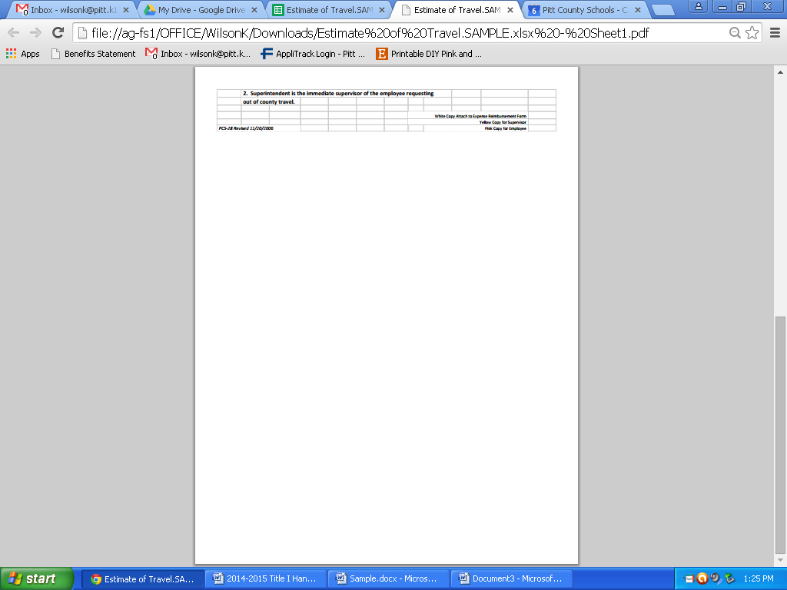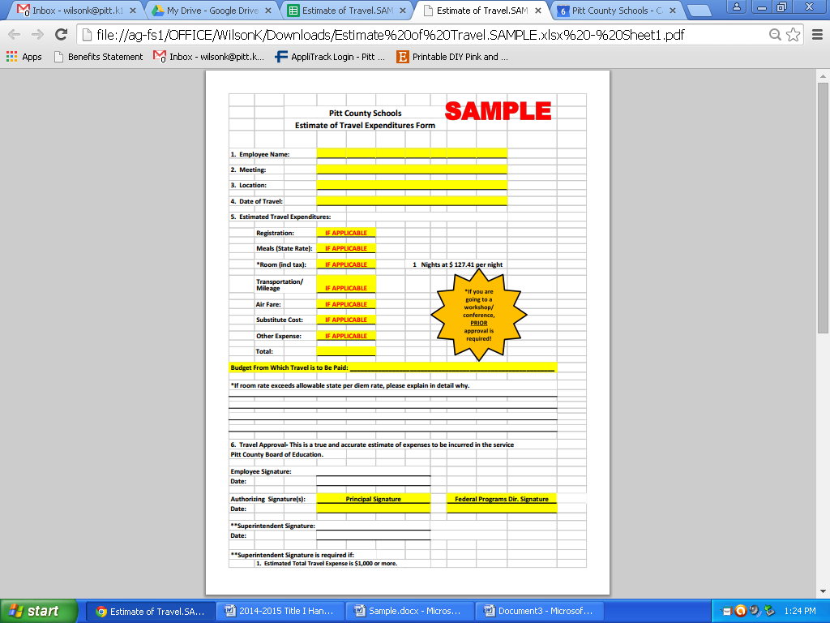

49

|  |  |  |  |  |  |  |  |  |  |  |  |  |  |  |  |  |  |  |  |  |  |  |  |  |  |  |  |  |  |  |  |  |  |  |
| --- | --- | --- | --- | --- | --- | --- | --- | --- | --- | --- | --- | --- | --- | --- | --- | --- | --- | --- | --- | --- | --- | --- | --- | --- | --- | --- | --- | --- | --- | --- | --- | --- | --- | --- |
|  |  |  | **PITT COUNTY BOARD OF EDUCATION PURCHASE ORDER AND RECEIVING REPORT** | | | | | | | | | | | | | | | |  | |  | |  | |  | |  | |  | |  | | | |
|  |  |  |  |  |  | |  | |  | |  | |  | |  | | **CENTRAL OFFICE USE ONLY** | | | | | | | | | | | | | | | | |
| CHARGE TO: | |  |  |  |  | |  | |  | |  | |  | |  | | Purchase  Order No._________________________________ | | | | | | | | | | | | | | | | |
| Pitt County Schools | | | |  |  | |  | |  | |  | |  | | Date: ____________________________________ | | | | | | | | | | | | | | | | | | |
| 1717 West Fifth Street | | | |  |  | |  | |  | |  | |  | |  | |  | |  | | |  | |  | |  | |  | |  | |  | |
| Greenville, NC 27834 | | | |  |  | |  | |  | |  | |  | |  | |  | |  | | |  | |  | |  | |  | |  | |  | |
|  |  |  |  |  |  | | INVOICE IN DUPLICATE | | | | | | | |  | |  | |  | | |  | |  | |  | |  | |  | |  | |
| **CENTRAL OFFICE USE ONLY** | | | |  |  | |  | |  | |  | |  | |  | |  | |  | | |  | |  | |  | |  | |  | |  | |
| VENDOR NO. | |  |  |  |  | |  | |  | |  | | | |  | |  | |  | | |  | |  | |  | |  | |  | |  |
|  |  |  |  |  |  | |  | |  | |  | |  | |  | | |  | |  | |  | |  | |  | |  |
|  |  |  |  |  |  | |  | |  | |  | |  | |  | |  | |  | | |  | |  | |  | |  | |  | |  |
|  |  |  |  |  |  | |  | |  | | **Attention: First and Last Name** | | | | | | | |  | | |  | |  | |  | |  | |  | |  |
| Vendor: | **Vendor's Name** | | | | | |  | |  | | Ship to: | | **School Name** | | | | | | | |  | |  | |  | |  | | |  | |  | |
| Address: | **Address** | | | | | |  | |  | | Address: | | **Address** | | | | | | | |  | |  | |  | |  | | |  | |  | |
|  |  |  |  |  | |  | |  | |  | |  | |  | |  | |  | |  | |  |  | |  | | |  | |  | |  |
| PHONE: ( ) | |  |  |  | |  | |  | |  | | PHONE: ( ) | | | |  | |  | |  | |  |  | |  | | |  | |  | |  |
| FAX: ( ) | |  |  |  | |  | |  | |  | | FAX: ( ) | | | |  | |  | |  | |  |  | |  | | |  | |  | |  |
|  |  |  |  |  | |  | |  | |  | |  | |  | |  | |  | |  | |  |  | |  | | |  | |  | |  |
|  |  |  |  |  | |  | |  | |  | |  | |  | |  | |  | |  | |  |  | |  | | |  | |  | |  |
| Quantity | |  | Part  Number |  | | Description | | | | | | | | | |  | | Unit Price | |  | | Total Cost | | | | | | | | | |  | |
| Ordered | Received |  | |
|  |  |  |  |  | |  | |  | |  | |  | |  | |  | |  | |  | |  |  | |  | | |  | |  | |  |
|  |  |  |  |  | | **SAMPLE COPY OF ORDERING ITEMS** | | | | | | | | | |  | |  | |  | |  |  | |  | | |  | |  | |  |
|  |  |  |  |  | |  | |  | |  | |  | |  | |  | |  | |  | |  |  | |  | | |  | |  | |  |
| 1 |  |  | **160103** |  | | Expo Eraser | | | | | | | | | |  | | $2.90 | |  | |  | $2.90 | | | | | | | | |  | |
| 2 |  |  | **330-5888** |  | | Expo Dry Erase Markers (pk of 6) | | | | | | | | | |  | | $9.90 | |  | |  | $19.80 | | | | | | | | |  | |
| 3 |  |  | **CA-A60354** |  | | Nonfiction Reading Books | | | | | | | | | |  | | $8.99 | |  | |  | $26.97 | | | | | | | | |  | |
| 4 |  |  | **OWA-8045-06** |  | | Big Box of Work Chunks | | | | | | | | | |  | | $24.99 | |  | |  | $99.95 | | | | | | | | |  | |
| 5 |  |  | **MDE-1254-3** |  | | "9 x 12" Magnetic Dry Erase Boards | | | | | | | | | |  | | $5.49 | |  | |  | $27.45 | | | | | | | | |  | |
|  |  |  |  |  | |  | |  | |  | |  | |  | |  | |  | |  | |  |  | |  | | |  | |  | |  |
| This instrument has been preaudited in the manner required by the School Budget and Fiscal Control Act.  **Controller** | | | | | | | | |  | | Gross Total | | | | | | | |  | |  | | $177.07 | | | | | | | |  | | |
|  | | Shipping Charges **(if applicable) 13%** | | | | | | | |  | |  | | $23.02 | | | | | | | |  | | |
| **Principal** | | | | | | | | |  | | Less _____**10%**____________Per Cent Discount | | | | | | | |  | |  | | $17.71 | | | | | | | |  | | |
|  | | Subtotal | | | | | | | |  | |  | | $217.80 | | | | | | | |  | | |
| **Authorized Agent Federal Programs Director** | | | | | | | | |  | | Plus N.C. Sales Tax (Compute on Subtotal) **7%** | | | | | | | |  | |  | | $15.24 | | | | | | | |  | | |
| **Received By person receiving items Dated Rec'd** | | | | | | | | |  | | **The percentages listed below are examples**   |  | | --- | | Total Net Cost | | | | | | | | |  | |  | | $233.04 | | | | | | | |  | | |
|  | | | | | | | | |  | |  | | | | | | | |  | |  | |  | |  | |  | | |  | |  | |
| Budget Code | | | | Invoice   Date | | | | | Invoice Number | | | | | | Invoice  Amount | | | | | |  | |  | |  | |  | | |  | |  | |
|  | |  | |  | | |  | |  | |
| **x.xxxx.xxx.xxx.xxx** | | | | xx/xx /xx | | | | | xxxxxxxx | | | | | | $xxx.xx | | | | | |  | | Total   Invoices | | | | | | | | |  | |
|  | | | |  | | | | |  | | | | | |  | | | | | |  | |  | | | | | | | | |  | |
|  | | | |  | | | | |  | | | | | |  | | | | | |  | |  | |
|  | | | | | | | | | | | | | | | | | | | | |  | |  | | | | | | | | |  | |
|  | | | | | | | | | | | | | | | | | | | | | | | | | | | | | | | |  | |
| **VENDOR'S COPY** | | | | | | | | | | | | | | | | | | | | | | | | | | | | | | | |  | |
|  |  |  | **PITT COUNTY BOARD OF EDUCATION PURCHASE ORDER AND RECEIVING REPORT** | | | | | | | | | | | | | | | |  | |  | |  | |  | |  | | |  | |  | | |
|  |  |  |  |  |  | |  | |  | |  | |  | |  | | **CENTRAL OFFICE USE ONLY** | | | | | | | | | | | | | | | | |
| CHARGE TO: | |  |  |  |  | |  | |  | |  | |  | |  | | Purchase  Order No._________________________________ | | | | | | | | | | | | | | | | |
| Pitt County Schools | | | |  |  | |  | |  | |  | |  | | Date: ____________________________________ | | | | | | | | | | | | | | | | | | |
| 1717 West Fifth Street | | | |  |  | |  | |  | |  | |  | |  | |  | |  | |  | |  | |  | |  | |  | |  | |
| Greenville, NC 27834 | | | |  |  | |  | |  | |  | |  | |  | |  | |  | |  | |  | |  | |  | |  | |  | |
|  |  |  |  |  |  | | INVOICE IN DUPLICATE | | | | | | | |  | |  | |  | |  | |  | |  | |  | |  | |  | |
| **CENTRAL OFFICE USE ONLY** | | | |  |  | |  | |  | |  | |  | |  | |  | |  | |  | |  | |  | |  | |  | |  | |
| VENDOR NO. | |  |  |  |  | |  | |  | |  | | | |  | |  | |  | |  | |  | |  | |  | |  | |  | |
|  |  |  |  |  |  | |  | |  | |  | |  | |  | |  | |  | |  | |  | |  | |  | |
|  |  |  |  |  |  | |  | |  | |  | |  | |  | |  | |  | |  | |  | |  | |  | |  | |  | |
|  |  |  |  |  |  | |  | |  | |  | | | | | | | |  | |  | |  | |  | |  | |  | |  | |
| Vendor: | **Vendor's Name** | | | | | |  | |  | | Ship to: | | **School Name** | | | | | | | |  | |  | |  | |  | |  | |  | | |
| Address: | **Address** | | | | | |  | |  | | Address: | | **Address** | | | | | | | |  | |  | |  | |  | |  | |  | | |
|  |  |  |  |  | |  | |  | |  | |  | |  | |  | |  | |  | |  |  | |  | | |  | |  | |  | |
| PHONE: ( ) | |  |  |  | |  | |  | |  | | PHONE: ( ) | | | |  | |  | |  | |  |  | |  | | |  | |  | |  | |
| FAX: ( ) | |  |  |  | |  | |  | |  | | FAX: ( ) | | | |  | |  | |  | |  |  | |  | | |  | |  | |  | |
|  |  |  |  |  | |  | |  | |  | |  | |  | |  | |  | |  | |  |  | |  | | |  | |  | |  | |
|  |  |  |  |  | |  | |  | |  | |  | |  | |  | |  | |  | |  |  | |  | | |  | |  | |  | |
| Quantity | |  | Part Number |  | | Description | | | | | | | | | |  | | Unit Price | |  | | Total Cost | | | | | | | | | |  | |
| Ordered | Received |  | |
|  |  |  |  |  | |  | |  | |  | |  | |  | |  | |  | |  | |  |  | |  | | |  | |  | |  | |
|  |  |  |  |  | | **SAMPLE COPY OF PARENT INVOLVEMENT**  **REIMBURSEMENT** | | | | | | | | | |  | |  | |  | |  |  | |  | | |  | |  | |  | |
|  |  |  |  |  | |  | |  | |  | |  | |  | |  | |  | |  | |  |  | |  | | |  | |  | |  | |
|  |  |  |  |  | | SAM’S CLUB | | | | | | | | | |  | |  | |  | |  | $17.90 | | | | | | | | |  | |
|  |  |  |  |  | |  | | | | | | | | | |  | |  | |  | |  |  | | | | | | | | |  | |
|  |  |  |  |  | | LITTLE CAESAR’S | | | | | | | | | |  | |  | |  | |  | $252.00 | | | | | | | | |  | |
|  |  |  |  |  | |  | | | | | | | | | |  | |  | |  | |  |  | | | | | | | | |  | |
|  |  |  |  |  | | CASH & CARRY | | | | | | | | | |  | |  | |  | |  | $9.74 | | | | | | | | |  | |
|  |  |  |  |  | |  | |  | |  | | **Reimbursement for snacks and/or supplies for Parent Involvement Workshop**  **(Workshop Title)**  **(Date)** | |  | |  | |  | |  | |  |  | |  | | |  | |  | |  | |
| This instrument has been preaudited in the manner required by the School Budget and Fiscal Control Act.  **Controller** | | | | | | | | |  | | Gross Total | | | | | | | |  | |  | | $279.64 | | | | | | | |  | | |
|  | | Shipping Charges | | | | | | | |  | |  | |  | | | | | | | |  | | |
| **Principal** | | | | | | | | |  | | Less _________________Per Cent Discount | | | | | | | |  | |  | |  | | | | | | | |  | | |
|  | | Subtotal | | | | | | | |  | |  | |  | | | | | | | |  | | |
| **Authorized Agent Federal Programs Director** | | | | | | | | |  | | Plus N.C. Sales Tax (Compute on Subtotal) | | | | | | | |  | |  | |  | | | | | | | |  | | |
| **Received By person receiving items Dated Rec'd** | | | | | | | | |  | | Total Net Cost | | | | | | | |  | |  | | $279.64 | | | | | | | |  | | |
|  | | | | | | | | |  | |  | | | | | | | |  | |  | |  | |  | |  | |  | |  | | |
| Budget Code | | | | Invoice   Date | | | | | Invoice Number | | | | | | Invoice  Amount | | | | | |  | |  | |  | |  | |  | |  | | |
|  | |  | |  | |  | |  | | |
| **3.5880.050.411.xxx (Supplies Expense)** | | | |  | | | | |  | | | | | |  | | | | | |  | | Total  Invoices | | | | | | | | |  | |
| **3.5880.050.459.xxx (Food Expense)** | | | |  | | | | |  | | | | | |  | | | | | |  | |  | | | | | | | | |  | |
|  | | | |  | | | | |  | | | | | |  | | | | | |  | |  | |
| **VENDOR’S COPY** | | | | | | | | | | | | | | | | | | | | |  | |  | | | | | | | | |  | |

**PURCHASE ORDER REVIEW**

Date: _________________________________________________

To: ___________________________________________________

School: _______________________________________________

**From: Federal Programs Director**

The attached Purchase Order is being returned to you due to the following:

______ P.O. is NOT in your plan

______ P.O. does not support school goals

______ P.O. not on budget sheet

______Wrong budget code

______Missing budget code or documentation

______Missing PO Request Form

______ Other:

_________________________________________________________________________________

_________________________________________________________________________________

_________________________________________________________________________________

_________________________________________________________________________________

Please direct any questions to: _________________________________________________________

**Contracts, Notice to Pay and Timesheets**



Title I Contracts

* Contracts are due to the Federal Programs office by the 5th of each month. Contracts received late may cause a delay in payment.

FYI: Please make sure before the employee start working in your building the proper paperwork has been completed (Ex: if a person has not worked in 90 days they must have a Background and Drug Screening). This is required for Retirees and Non-Retirees. If the employee has not had a Background Check and Drug Screening, you will need to fill out a Contract Check List (see forms). If the employee and the principal signed the Background and Drug Screening form, you can send the Contract Checklist directly to Pamela Miller for approval. Once the employee has had the Background and Drug Screening, a contract may be submitted to the Federal Programs Office. Be mindful that it is your responsibility to call and set up an appointment with Pamela Miller for the employee to get the Background and Drug Screening. Principal shall be notified by Human Resources for Approval.

* Please complete contract in Applitrack for Non-Employees or PCS Employees.
* If the consultant is a Pitt County Schools employee, he/she need to keep a time sheet to reflect hours worked.
* Contracts are to be signed by the principal or other designee (must be actual signature; stamped or copied signatures are not acceptable).
* Contracts are to be signed and dated prior to the first day of contracted service.
* Contracts need to include the following information:
* Dates of service (may span a period of time, i.e. Sept. 2023

through May 2024)-SPECIFIC TIMES (SEE SAMPLE CONTRACT ON

(PAGE 53)

* Employees cannot work outside of their contract!
* Object code 311-must have a valid, written contract to use this code for “Outside Contractors.”
* All representative conducting a workshop—need to use budget code 312.
* Contract must be specific:

-Who

-What

-When

-Where

* Title of job/duty (i.e. Title I Math tutor)
* School where tutor is employed
* Tutor’s daily or hourly rate of pay
* Specify time period
* Contract may state service is not to exceed the actual number of hours per month, or must not exceed said amount of pay over the course of the contract. This is optional (see sample copies of form).
* Tutors and Remediation Teachers getting paid on a contract cannot work more than 90 hours depending on eligibility of when he/she can start.
* Contracts must have a “do not” exceed amount listed.

* In order for a consultant to receive their pay in a timely manner, the following items must be submitted into Applitrack by the 5th day of the month:
* Notice to Pay
* Time-sheet
* Contract
* You **cannot** code a contract for Pitt County Schools' employees out of codes 411, 311, 461, or 312. The object code must begin with a “1”. If you do not know how to code the contract, contact the Federal Bookkeeperat the Central Office and she will assist you.
* You **can only** code employee contracts to a 100 object code.—143,198,196, and 197.
* When contracting an outside consultant, please use the Non-Employee Contract and include the original agreement.
* If contracts are returned due to errors or missing information, please resubmit in Applitrack with the necessary information. Check for signatures and budget codes
* In any case that the employee work over their time specified on the contract, the principal needs to initial beside the total week hours for that particular day (see sample timesheet on page 62).

**Contract Reminders**

* Complete paperwork at least 2 weeks **prior** to the date you want the employee to work.
* All timesheets are electronic; **paper time sheets are no longer accepted.** Be sure you are using the one that calculates your Rate of Pay.

* **Employee Contract** should be used when the principal has given the employee a specific task to work with students (what, when, where and how)
* **Non-Employee Contract** should be used when you contract someone to provide a workshop, professional development, training, that is **NOT** a Pitt County Schools employee.
* **Employees should not be working in the building, until they have been cleared by HR and Federal Programs have a stamped copy of the contract.** **This includes a Background and Drug Screening.**
* Employees working more than 4 hours have to show a break on the timesheet. If they work less than 4 hours, a break is not required.
* In order for the employee to be paid in a timely manner, contracts need to be sent to Federal Programs by the 5th of each month.
* Contact the Finance Department about hourly/daily rate of pay.
* **Remediation teachers are REQUIRED to complete a student roster spreadsheet monthly.**
* **DO NOT put the employee’s social security number on the contract, use the employee id number.**

**Sample Contracts**

During School Remediation

Sally Sue will serve as a Math Remediation Teacher for Happy School from September 11, 2023 - May 31, 2024.  She will work from 8:15 am - 2:15 pm with a 30 minute lunch break Monday - Friday; not to exceed 27.5 hours per week. She will follow the PCS Student Calendar. Sally Sue will be paid $25 per hour, not to exceed $22,000 over the course of the contract period. Budget Code 3.5330.050.143.schoolcode

After School Remediation

Johnny Apple will provide after school math tutoring from 3:30 - 4:30 Tuesday-Thursday at a rate of $25 per hour.  Tutoring will begin on Oct. 1, 2023 - May 30, 2024, not to exceed 3 hours per week or $2,400 over the course of the contract period. Attendance records will be kept to document student participation in tutoring. Budget Code 3.5350.050.198.schoolcode

Title I Timesheets

* All timesheets, contracts and notice to pay (NTP) have to be submitted in Applitrack.
* Timesheets and NTP are to be signed and dated on or after the last day of service.
* We cannot process a contract, time sheet with crossed out information without an initials or white-out on the document.
* Please include budget codes on timesheet, NTP and contracts.
* If an employee works for more than 4 hours, the employee needs to show a lunch or a break on the timesheet
* If an employee works less than 4 hours they do not have to show a lunch or a break.
* When an employee changes their regular scheduled hours, principals need to initial by the time, which indicates the principal’s approval.
* Contracted employees CAN NOT come back or stay over to make up time; employee needs to adhere to the original contract. Employees may change the day to another day with principal‘s approval.
* If you extended the employees hours, you MUST complete a REVISED contract.

Please write “Revised Contract” on the updated contract

* Paperwork will not be processed, until the revised contract is stamped (revise contract should be turned in prior to the employee being paid
* Dual Employees that are not working with the students, the principal signature is required.
* The Employee and Principal **MUST** sign and date the timesheet. Please do not type in signature, it has to be original.
* When an employee is contracted for remediation, the employee **ONLY** works when they are with students!

Bus Drivers:

* Timesheets for bus drivers paid with Title I funds need to be coded at the school level, signed by the principal or designee, and sent to the Federal Programs Office for Federal Programs Director signature.
* **Fill out timesheet completely**. Include hourly rate of pay. Tally all columns.
* We will forward approved timesheet to the appropriate Central Office payroll clerk

**Budgeting Codes**

**Site Codes**

000 = District-wide Initiatives (Shared between Title I schools)

810 = Administrative Set-Aside

840 = Preschool - Early Education

860 = Equitable Services for Private Schools

**Fund Code**

3 = Federal Grant Fund Purpose Codes

The reason for which something exists and/or used to accomplish the objectives of a PSU. For budgeting and accounting purposes, expenditures are classified into five purposes as follows:

- 5000 Instructional Services

- 7000 Ancillary Services

- 9000 Capital Outlay

- 6000 System-Wide Support Services

- 8000 Non-Programmed Charges

**Object Codes**

Are the result of a specific expenditure, directly part or related to the purpose, and the next set of digits after the purpose code. There are seven major object categories in the chart of accounts:

- 100 Salaries

- 200 Employer Provided Benefits

- 300 Purchased Services

- 400 Supplies and Materials

- 500 Capital Outlay

- 600 Reserved for Future Use

- 700 Transfer

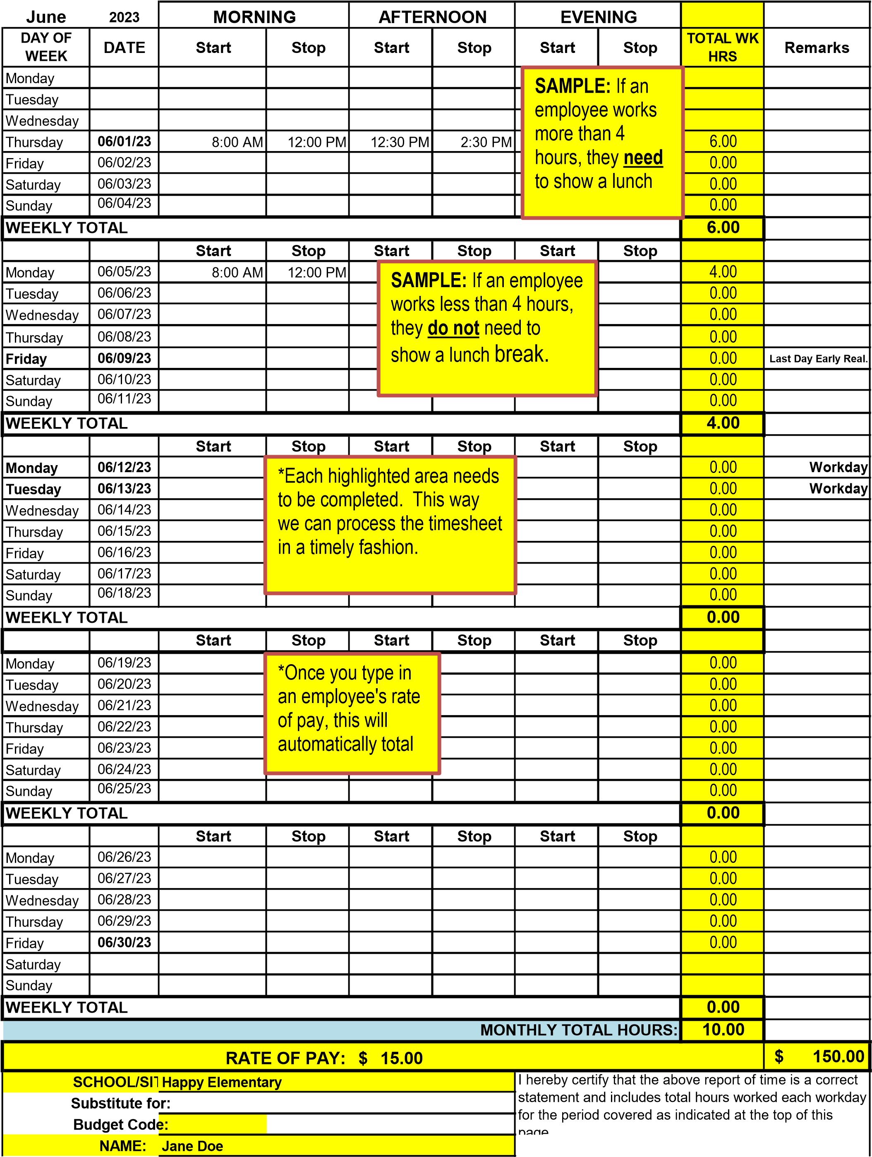

**Parent Family Engagement**



**Parent Family Engagement Activities**

**ESSA describes the parents’ right to be involved in Title I and requires that, “…programs, activities, and procedures shall be planned and implemented with meaningful consultation with parents of participating children.”**

1. Federal law mandates that Title I Schools include parents in the school improvement process and on the school improvement team.
2. State guidelines recommend that at least two non-Pitt County School employees serve as parent representatives on the School Improvement Team.

**Each summer, the school will:**

1. Submit a copy of the revised **Parent Policy** and **Parent–School-Student Compact**. Incorporate parent recommendations and annual evaluation results.
2. Each school must designate a School Contact (staff member) to serve as liaison between the school and the District Parent Involvement Coordinator
3. Each school must designate at least one parent representative to serve on the District Parent Involvement Policy and LEA Improvement Plan subcommittees.
4. Parents are asked to annually evaluate the parental involvement program at each school.

**Parent Engagement Allocation:**

School systems must reserve at least one percent of their Title I allocation for parental engagement activities, with 95% of the reserved funds passed to Title I schools. As a result, each school receives a parent engagement allocation based on the number of students in poverty. These funds are to be used to support parent engagement related activities with a purpose of improving student achievement as described in your prioritized plan.

1. Parents must be involved in planning and budget development processes.
2. Funds not used in the allocated year, will be added to the parent involvement allocation for the following year, from the regular school allocation.

*Funds may be budgeted to cover expenses of parents participating in workshops

promoting parental engagement. Remember that food costs may not exceed $4.50 per person.

*For ALL Title I workshops, please send to Twanda Staton a copy of the attendance sheet.

**To be reimbursed—paperwork needs to be submitted within the same month!**



**Pitt County Schools**

**parent engagement evaluation (Include New Form)**

**2023 - 2024**

**Dear Parent/Guardian,**

**We are always trying to improve our partnership with parents. Please help us by placing a check on the line next to the appropriate question and return the completed form to your child's teacher. Thank you for your assistance.**

**YES NO**

1. **Did you receive information about your child's school program?**

**____ ____**

1. **Did you observe/visit your child during the year in his/her classes? ____ ____**

**What grade is your child in? ____________________**

1. **Did you attend any meetings or parent sessions at your child’s school? ____ ____**

**(e.g., Gateway; EOG meeting; Math, Science, Writing night;**

**Parent/Student/School Compact meeting; etc.)**

1. **Were the meetings held at a convenient time for you? ____ ____**
2. **Did you find these meetings or activities helpful to you and your child? ____ ____**
3. **Have you been contacted by your child’s teacher during**

**the school year? ____ ____**

1. **Have you received progress reports for your child during the**

**school year? ____ ____**

1. **Were our methods of communications effective? (phone, email, text, etc.) ____ ____**
2. **Were you asked to review and give input into your school’s Parent /Student**

**/School Compact? ____ ____**

**10. Was the information you received in a language you could understand? ____ ____**

**LOOKING AHEAD**

**What topic(s) would you like to have discussed at a parent meeting?**

**________________________________________________________________________________**

**________________________________________________________________________________**

**Please write your suggestions for program improvement in the spaces below.**

**________________________________________________________________________________**

**________________________________________________________________________________**

**How would you like to be involved next year?**

**_________________________________________________________________________________**

**_________________________________________________________________________________**

**Thank you again for your assistance in completing this form and returning it to your child’s teacher.**



**Example Elementary School**

**Title I**

**Parent Family Engagement Policy**

Section 1118 of the ESSA Waiver formally replacing ESEA requires the involvement of parents of participating children in the planning and implementation of District and School Title I projects. Such programs, activities, and procedures shall be planned and implemented with meaningful consultation with parents of participating children.

**This meeting is to inform parent about their rights under the law and to provide them with information that will allow them to be fully active in their child’s education.**

**To involve parents in the policy process we will:**

* Encourage all parents to attend the Example Meeting, held at the beginning of the year, to learn about Example School’s participation in Title I, the requirements of the Title I program, and your rights as parents to be involved.
* Hold Title I Parent Involvement meetings at different times and on different days, and may provide transportation, child care, or home visits to accommodate the scheduling needs of our parents.
* Involve parents in an organized, ongoing, and timely way in the planning, review, and improvement of Example School’s Title I programs, including the planning, review, and improvement of the school parental involvement policy and the joint development of the schoolwide program plan (if applicable).
* Provide parents with timely information about Title I programs, a description and explanation of the curriculum in use at Example School, the forms of academic assessment used to measure student progress, and the proficiency levels students are expected to meet.
* Upon request, provide parents with opportunities for regular meetings to formulate suggestions and to participate, as appropriate, in decisions relating to the education of their children, and respond to suggestions as soon as possible.
* If Example School’s schoolwide program plan (if applicable) is not satisfactory to the parents, we are required to submit any parent comments on the plan to Pitt County Schools Federal Programs Office.

**To share responsibilities for high student academic achievement we will:**

* Develop with parents, a school-parent compact that outlines how parents, school staff, and students will share responsibility for improved student academic achievement.
* Help parents create a supportive and effective learning environment at home by providing information on the importance of attendance, homework completion and the positive use of extracurricular time; limiting time spent watching television and playing video games; and volunteering in their child’s classroom and participating in decisions relating to the education of their children.
* Address the importance of communication between teachers and parents through parent-teacher conferences, progress reports, and provide reasonable access to staff, opportunities to volunteer and participate in their child’s class, and observe classroom activities.
* Parent Meetings will be held throughout the year, which gives parents a chance to be actively involved in their child’s education.

**To build capacity for involvement we will:**

* Ensure effective involvement of parents and support partnerships among the Example School, our parents, and our community to improve student academic achievement.
* Provide assistance to parents in understanding topics such as the State’s academic content standards, the State’s student academic standards, State and Local assessments, the requirements of Title I, and how to monitor your child’s progress and work with educators to improve the achievement of your children.
* Provide parents with materials and training, such as literacy materials and technology training, to help them work with their children to improve their achievement, and to foster parental involvement.
* Educate teachers and school staff about the value of the contributions of parents; how to reach out to, communicate with, and work with parents as equal partners; implement and coordinate parent programs; and build ties between the parents, the school, and the community.
* Coordinate and integrate Title I parent programs and activities with other programs, and conduct activities and provide resources that encourage and support parents in more fully participating in the education of their children.
* Ensure that information related to school and parent programs, meetings, and other activities is sent to parents in a format and to the extent practicable, in a language the parents can understand.
* Provide other reasonable support for parental involvement activities as requested.

**To be accessible to all parents we will:**

* Provide full opportunities for the participation of parents with limited English proficiency, parents with disabilities, and parents of migratory children.
* Provide information related to Pitt County Schools, Example School, plans, meeting notices, report cards, and other accountability information in a format, and to the extent practicable, in a language that parents understand.

**Example Elementary School Title I Program Description:**

**Title I Parent Family Engagement Policy Requirements**

Each school must jointly develop with, agree upon, and distribute to parents, a written parental involvement policy. The policy must specify how the school will address each of the following required components:

1. **Convene an annual meeting**, at a convenient time, to which all parents of participating children shall be invited and encouraged to attend, to inform parents of their school’s participation in Title I, explain the requirements of the Title I program, and explain the right of the parents to be involved.
2. **Offer a flexible number of meetings,** such as meetings in the morning or evening;
3. **Involve parents in an organized, ongoing, and timely way,** in planning, review, and improvement of Title I programs, including the planning, review, and improvement of the school parental involvement policy and the joint development of the schoolwide program plan;
4. **Provide timely information about**: Title I, Part A Programs, school performance profiles, assessment results of their child’s performance, a description and explanation of the curriculum, assessment forms, proficiency levels, and state standards;
5. **Opportunities for regular meetings** to participate in decision-making;
6. **Provide for parents’ comments**, if the schoolwide program plan is not satisfactory to the parents of participating children. The school is required to submit any parent comments on the plan when the school makes the plan available to the LEA;
7. **Develop a School-Parent Compact**, jointly with parents, outlining how parents, the entire school staff, and students will share the responsibility for improved student academic achievement, and how the school and parents will build and develop a partnership to help children achieve State standards;
8. **Build capacity for involvement by providing parents assistance** in understanding performance standards, assessments, monitoring their child’s progress, and participating in decisions relating to the education of their child;
9. **Provide materials and training** to help parents work with their children (literacy training, computer skills, homework assistance/workshops, family literacy nights, adult ESL, GED, etc.):
10. **Educate teachers and other staff how work with parents, with the assistance of parents**;
11. **Coordinate and integrate parental involvement programs/activities**;
12. **Ensure that all information is understandable**; and
13. **Provide full opportunities for participation of parents with limited English proficiency and parents with disabilities**.

**In addition, it is optional for the policy to contain information about the following:**

* Adopt and implement model approaches to improving parental involvement;
* Develop appropriate roles for community-based organizations and businesses;
* Involve parents in the development of training for teachers, principals, and other educators to improve the effectiveness of the training;
* If the LEA has exhausted all other reasonably available sources of funding, Title I funds may be used to provide necessary literacy training;
* Pay reasonable and necessary expenses associated with local parental involvement activities, including transportation and child care cost;
* Train parents to enhance the involvement of other parents; and
* Arrange school meetings at a variety of times.

|  |
| --- |
| **School Name: Year:** |

**NCLB Parental Family Engagement Policy Requirements**

**& School Parental Involvement Plan Worksheet**

|  |
| --- |
| **Section 1118 of the ESEA Waiver formally replacing No Child Left Behind Act (NCLB) requires the involvement of parents of participating children in the planning and implementation of District and School Title I projects. Such programs, activities, and procedures shall be planned and implemented with meaningful consultation with parents of participating children.** |

* Each school must offer a minimum of 5 parent activities/meetings; the District Parent Involvement Specialist will provide a maximum of 3 activities/meetings per school.

**(*Schools must have 5 or more parents attending in order to be reimbursed.)**

* Using the descriptions below, create your school’s Parental Involvement Policy.
* Distribute the Parental Involvement Policy to all faculty and staff at the start of the year (Student/Staff Handbook);
* Distribute the Parental Involvement Policy to all parents at the start of the year;
* Distribute the Parental Involvement Policy to parents of newly enrolled students during the year; and
* Copies of your Parental Involvement Policy must be available in the front office (flyers, brochure, etc).
* Parent Engagement Plan must include, in detail, how you will meet each policy requirement by answering the attached questions (See questions A-F and 1-15).
* As documentation is collected and completed, add documentation to Title I website folders.
* Review Statement of Assurance with completed signatures for each school.

**A. List the names and roles (teachers, administrators, parents, etc.) of persons involved in developing your school’s Parental**

**Involvement Policy (you may add more lines if needed).**

|  |  |
| --- | --- |
| **Name** | **Role** |
|  |  |
|  |  |
|  |  |
|  |  |
|  |  |
|  |  |
|  |  |
|  |  |
|  |  |
|  |  |

**B. Please complete the attached matrix about Parent Involvement at your school. Remember to include parents and staff**

**When completing this plan.**

**Parent Family Engagement Plan**

**School: __________________________________ Year: __________________________**

**\*Section 1118C – Documentation may include invitations, meeting agendas, sign-in sheets, minutes, calendars, etc.**

**\*Each school jointly develop with, agree and distribute to parents, a written parental involvement policy must specify how the school address each of the following required components:**

|  |  |  |  |
| --- | --- | --- | --- |
| **Requirements** | **Date(s)** | **Events/Activities** | **Documentation** |
| * Annual Meeting at a convenient time, to inform parents of their school participation in Title I and explain the requirements of the Title I program |  |  |  |
| * Explain how parents are involved in supporting Parent Involvement Policy and Comprehensive School Plans |  |  |  |
| * School’s responsibility to provide high-quality curriculum in a supportive and effective learning environment. How do you inform parents about the PCS School-Parent Compact |  |  |  |
| * Communication between teacher and parents on an on-going basis about child’s achievement, progress reports or opportunities to volunteer. Explain your school process. |  |  |  |
| **Requirements** | **Date(s)** | **Events/Activities** | **Documentation** |
| * Parent engagement training that support parents in helping their child at home   * List parent workshops |  |  |  |
| * Information related to school and parent programs,   How does the school present information to parents in a language that they understand? Provide full opportunities for participation of parent with English proficiency and parents with disabilities |  |  |  |
| * **Parent Communication:**   Explain how the schools enhance the home-school relationship and keeping them informed about school activities. Educate teachers and other staff how to work with parents |  |  |  |

**Forms**



**Semi-Annual Blanket Certification**

**Pre-K Teachers**

**School Name: _________________________________________**

**I hereby certify that the employees listed below, who are paid from Title 1 and other funds (Title 1, NCPK, and EC) spent their time & effort on Pre-K activities for the period of August 1, 20XX through December 31, 20XX.**

**Names of Staff Paid with Blended Funds Teacher**

**_________________________________ ____________________**

**_________________________________ ____________________**

**_________________________________ ____________________**

**_________________________________ ____________________**

**_________________________________ ____________________**

**_________________________________ ____________________**

**_________________________________ ____________________**

**_________________________________ ____________________**

**_________________________________ ____________________**

**___________________________ __________________________**

**Supervisor Signature Date**

**Send the ORIGINAL to: Central Office Annex– Federal Programs**

**\*\*Do Not Fax\***

**Semi-Annual Blanket Certification**

**Pre-K Teachers**

**School Name: _________________________________________**

**I hereby certify that the employees listed below, who are paid from Title 1 and other funds (Title 1, NCPK, and EC) spent their time & effort on Pre-K activities for the period of January 1, 20XX through June 30, 20XX.**

**Names of Staff Paid with Blended Funds Teacher**

**_________________________________ ____________________**

**_________________________________ ____________________**

**_________________________________ ____________________**

**_________________________________ ____________________**

**_________________________________ ____________________**

**_________________________________ ____________________**

**_________________________________ ____________________**

**_________________________________ ____________________**

**_________________________________ ____________________**

**___________________________ __________________________**

**Supervisor Signature Date**

**Send the ORIGINAL to: Central Office Annex – Federal Programs**

**\*\*Do Not Fax\*\***

**Schoolwide Schools**

**Semi-Annual Blanket Certification**

**Federal PRC 050 Title 1**

**School Name: _________________________________________**

**I hereby certify that the employees listed below, who are paid from Title 1 funds, spent 100%* of their time & effort on Title 1 Schoolwide activities for the period of August 1, 20XX through December 31, 20XX.**

*Do NOT change or cross out 100%!

### Names of Staff Paid with Title 1 Funds Teacher or TA?

**_________________________________ ____________________**

**_________________________________ ____________________**

**_________________________________ ____________________**

**_________________________________ ____________________**

**_________________________________ ____________________**

**_________________________________ ____________________**

**________________________________ ____________________**

**___________________________ __________________________**

**Supervisor Signature Date**

**Keep a copy for yourself, put a copy in the Title 1 Notebook and send the ORIGINAL to: Central Office Annex -Federal Programs**

**\*\*Do Not Fax\*\***

**Schoolwide Schools**

**Semi-Annual Blanket Certification**

**Federal PRC 050 Title 1**

**School Name: _________________________________________**

**I hereby certify that the employees listed below, who are paid from Title 1 funds, spent 100%* of their time & effort on Title 1 Schoolwide activities for the period of January 1, 20XX through June 30, 20XX.**

*Do NOT change or cross out 100%!

### Names of Staff Paid with Title 1 Funds Teacher or TA?

**_________________________________ ____________________**

**_________________________________ ____________________**

**_________________________________ ____________________**

**_________________________________ ____________________**

**_________________________________ ____________________**

**_________________________________ ____________________**

**_________________________________ ____________________**

**_______________________________ __________________________**

**Supervisor Signature Date** (Cannot be before 12/31)

**Keep a copy for yourself, put a copy in the Title 1 Notebook and send the ORIGINAL to: Central Office Annex -Federal Programs**

**\*\*Do Not Fax\*\***

**Pitt County Schools**

**Title I Parent Meeting Sign-In Sheet**

**Name of Meeting: _______________________________________________________**

|  |  |  |  |  |  |  |
| --- | --- | --- | --- | --- | --- | --- |
| **School:** | |  | | | | |
| **Date of Meeting:** | |  | | | **Time:** |  |
| **Topic of Workshop:**   |  |  |  | | --- | --- | --- | | **Student Name** | **Parent Name** | **Teacher Name** | | 1. |  |  | | 2. |  |  | | 3. |  |  | | 4. |  |  | | 5. |  |  | | 6. |  |  | | 7. |  |  | | 8. |  |  | | 9. |  |  | | 10. |  |  | | 11. |  |  | | 12. |  |  | | 13. |  |  | | 14. |  |  | | 15. |  |  | | 16. |  |  | | 17. |  |  | | 18. |  |  | | 19. |  |  | | 20. |  |  | | |  | | | | |
|  |  | |  |  | | |
|  |  | |  |  | | |
|  | | | | | | |

**Other Members (Title I Teachers, Classroom Teachers, Principals, etc.)**

|  |  |  |  |
| --- | --- | --- | --- |
| 1. |  | 6. |  |
| 2. |  | 7. |  |
| 3. |  | 8. |  |
| 4. |  | 9. |  |
| 5. |  | 10. |  |
|  | | | |
| **Submitted by:** | | | |

**MOVE MONEY FORM**

**Pitt County Schools Federal Funds**

**School Year ______**

Authorization to move current budget allocations

Please transfer from: Please transfer to:

Account Amount Account Amount

_____________________ $__________ __________________ $___________

_____________________ $__________ __________________ $___________

_____________________ $__________ __________________ $___________

_____________________ $__________ __________________ $___________

_____________________ $__________ __________________ $___________

Total transfer from $__________ Total transfer to $___________

**Total “Transfer from” must equal Total “Transfer to”**

**\*\*\*\*\*\*\*\*\*\*\*\*\*\*\*\*\*\*\*\*\*\*\*\*\*\*\*\*\*\*\*\*\*\*\*\*\*\*\*\*\*\*\*\*\*\*\*\*\*\*\*\*\*\*\*\*\*\*\*\*\*\*\*\*\*\*\*\*\*\*\*\*\*\*\*\*\*\*\*\*\*\*\*\***

School ______________________________________

Authorized By_________________________________ Date______________________________

Principal’s Signature

Director______________________________________ Date_______________________________

Complete form: Original – to Finance Office/Federal Bookkeeper

Yellow copy – retain by Director’s office

Pink copy – retain by School

**\*Consider this an automatic process unless you hear from the Central Office\***

**PCS Title I Purchase Order**

**Request Form**

School Name:  Click or tap here to enter text. School Number:   Enter text.

Date funds are needed:  Click or tap here to enter text.

Purpose of the purchase (how does this relate to your Title I plan):

Click or tap here to enter text.

What school improvement goal does this purchase address?

Click or tap here to enter text.

Description of items to be purchased:

Click or tap here to enter text.

Vendor: Click or tap here to enter text.

Budget Code: Click or tap here to enter text.

|  |
| --- |
| Workshop Related:  Yes   No  Workshop Date: Click or tap here to enter text. Registration Deadline: Enter a date.  Name of Workshop: Click or tap here to enter text.  Names of Staff Members Attending: Click or tap here to enter text.  *Include a copy of the Estimate of Travel Expense Form* |

Key Questions

1. Is it necessary?  Yes No
2. Is it reasonable?  Yes No
3. Is it allowable?  Yes  No

Principal Signature:       ________________________________              Date: ____________

*May be electronic*